**Java III Application Programming**

**Project Status and Design Report**

|  |  |
| --- | --- |
| **Topic:** | Milestone 2 |
| **Date:** | July 22, 2018 |
| **Revision:** | 1.2 |
| **Author:** | Richard Boyd |
| **Weekly Status Summary:** | |  |  |  | | --- | --- | --- | | **User Story** | **Hours**  **Worked** | **Hours Remaining** | | Created login, register, register confirmation, and main pages. Created Login and Register controllers. Created User and Project classes, as well as the ExampleProjects class to generate example projects. | 4.5 | 0 | |
| **GIT URL:**  https://github.com/RichardvBoyd2/YouTubeProjectManager | |

**Design Documentation**

**General Technical Approach:**

This will be a web-based application for brainstorming, tracking, and organizing content ideas for a collaborative YouTube channel with more than one creator. It will display projects in a list showing what type of content it is, a title, its current production status, its scheduled release date, and which creators are involved (single or multiple). It will allow the creators to add projects or edit them from the main list page. Adding or editing them will open the project page that allows the users to populate fields of the project information.

**Key Technical Design Decisions:**

I’m using JSF and Facelets as covered in this section. I also plan to use an external .css file but this hasn’t been covered and I’m encountering issues with implementing this.

**Known Issues:**

* Can’t get external .css file to work for some reason.
* Can’t change Creators attribute to an ArrayList until database functionality is added

**Risks:**

|  |  |  |  |
| --- | --- | --- | --- |
| Risk | Details | Strategy for Risk **Avoidance** | Strategy for **Mitigation** |
| Code breaking issues that I don’t understand | When implementing a new feature the code throws errors I am not familiar with. | Fully understand code that I am about to implement and consider how it will effect the application as a whole. | Reach out for help to professor and online about errors that I don’t understand. |
| Personal emergency | Sickness or injury (self or loved one), significant property damage or theft, etc. | Potentially unavoidable | Work ahead when I have free time to develop a cushion of time to sort out the situation. |

**ER Diagram:**

*N/A at this time.*

**DDL Scripts:**

*N/A at this time.*

**Sitemap Diagram:**

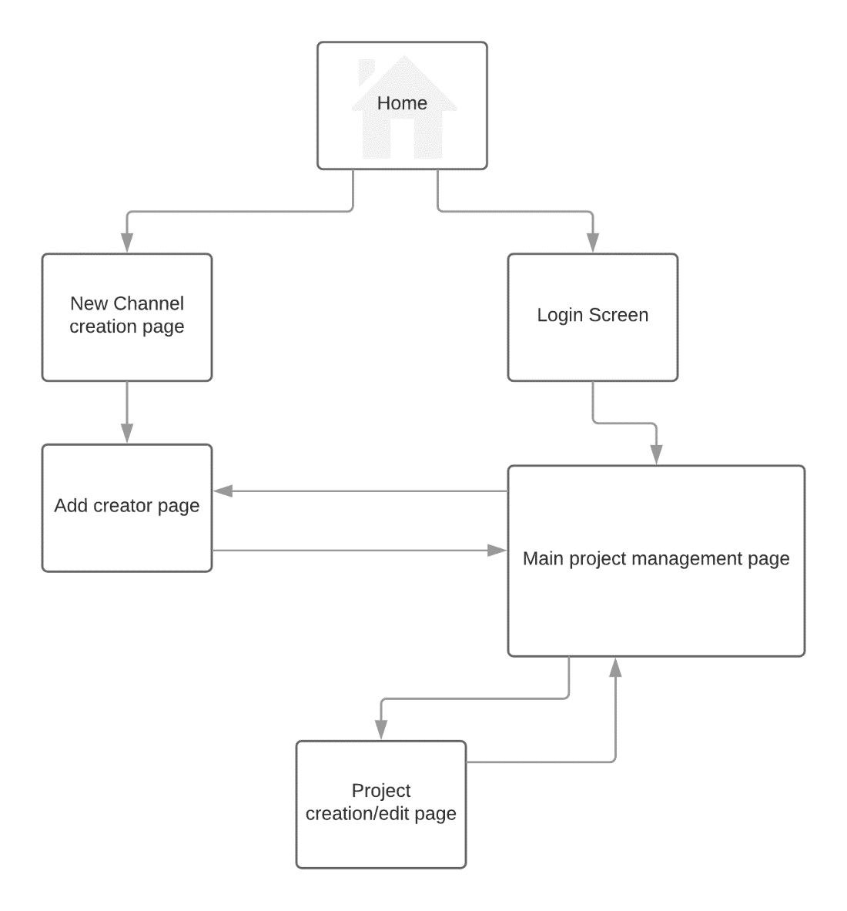

**User Interface Diagrams:**

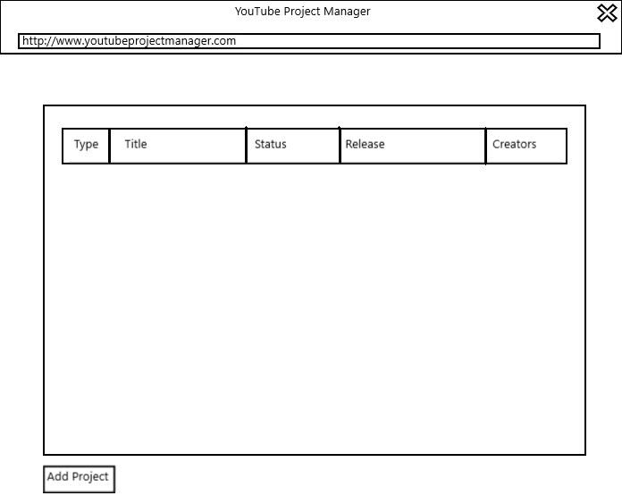

**Class Diagrams:**

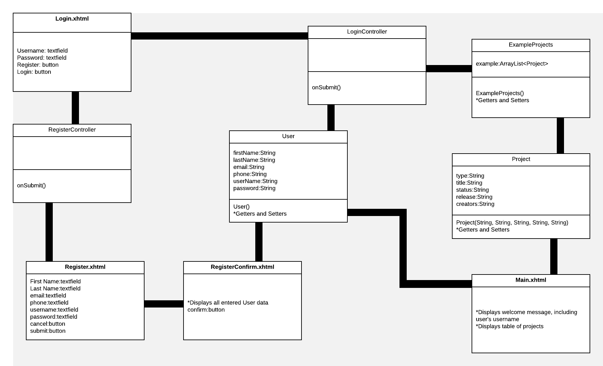

**Service API Design:**

*N/A at this time.*

**Security Design:**

*N/A at this time.*

**Other Documentation:**

*N/A at this time.*